SOFTWARE DEVELOPER - Bucharest Office

About dcs plus
Since 2002, we are committed to designing and developing technology solutions for the travel and tourism industry. For over a decade, driven by passion, dcs plus has connected travel to technology, in direct response to the challenges and needs of the travel and tourism professionals.
We are committed to innovation and, through our solutions, we aim to deliver excellence to travel professionals, regardless of size, business model or market. We provide them the right tools needed to optimize their capabilities and improve their business performance that will shape into success stories.
- Ranked in Deloitte Technology Fast 500 EMEA
- Software localized in more than 50 markets worldwide
- More than 18 years of helping companies grow their travel business
- 300,000 travel agents all over the world are using dcs plus travel software

About the Team
We are engineers. We are computer scientists. We are techies.

The dcs plus Product Engineering team is responsible for creating and evolving the dcs plus products and services. The team also uses different tools and technology to deliver a highly scalable and dynamic platform to a fast-growing business offering covering integration with multiple partner heterogeneous technology platforms/ content-feeds. The team comprises a highly talented team of programmers, testing engineers, business analyst with independent module-based product ownership requiring direct conversation with the business and marketing teams for appropriate development planning.

This team makes sure that our products can support millions of bookings run through our platforms in more than 50+ markets.

About the Job (Role: Software Developer)
The Software Developer’s responsibilities include the support and development of all key platform components and products of dcs plus. S/he will work with other technical teams in development and work towards implementing latest technologies to create & improve dcs plus products.

What’s in it for you?
- A role inside a growing company activating in a changing and versatile industry.
- Opportunity for learning, development, and recognition in a young and family-like environment.
- Continuous growth ensured by training & coaching programs & constant feedback sessions.
- Certainty and stability of the team and of the working environment.

Responsibilities
- Code review and make sure delivery on time as per our quality standards
- Develop components, modules and/or algorithms for the dcs plus platform that follow OOAD methodologies, and software design patterns.
- Provide technical resolution of issues on mission critical systems.
- Innovates and proposes his ideas to the Software Architect.
- Hands-on development of proof of concepts and evaluates new technologies.
- Performs a programming assignment requiring knowledge of established programming procedures and data processing requirements.
- Designs and converts the required features into application functionalities.
- Follows the architecture, guides, and practices that the Software Architect sets.

Essential Prior Expertise
- 2+ years’ experience with backend development in PHP.
- 2+ years’ experience with MySQL.
- Experience working with version control systems (Git).
- Good OOP understanding and basic design patterns.
- Experience working with and building SOAP APIs.
- Experience working with XMLs (writters, processors and creating definition schemes in the form of XSD).
- Experience in working with template engines (like Twig, Smarty).
- Basic knowledge of Linux operating system (OS files structure, permissions, cronjobs, simple commands).

Nice to have skill set but not mandatory
- Experience with PHP frameworks such as Symfony, Laminas (formerly known as Zend Framework), Mezzio (formerly known as Zend Expressive) - should have hands-on coding experience with any of these frameworks.
- Knowledge and /or experience working with a layered architecture and Domain Driven Design methodology.
- Experience working with and building REST APIs.
- Knowledge and/or experience with shell scripting.
- Knowledge and/or experience in working with jQuery, especially in building plugins.

Desired Qualifications
- Experience of developing high-performance applications using various PHP frameworks and other supporting technologies.
- Solid troubleshooting, problem solving and analytical skills and the ability to reach innovative options quickly required.
- Ability to work well under pressure and tight deadlines.
- Enthusiastic, performance-driven self-starter, strategic mindset and team player.
- Good understanding of design principles and good coding practices.

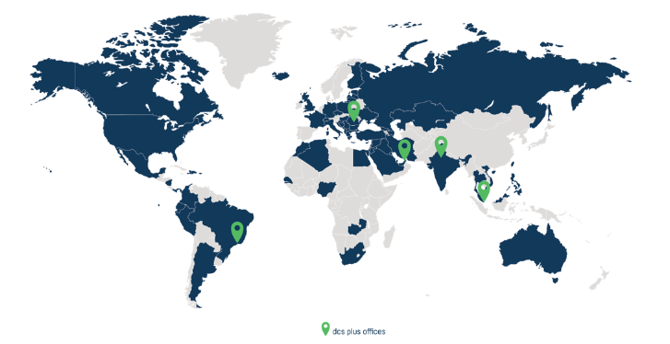
Job Location: Bucharest

